User clicks Project ID
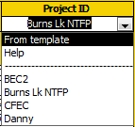
Metadata can come from a template – data already partially entered – or select from metadata already within the project.
When using a template, the user will be asked to give it a new name so as to not confuse it with the template. VPro will make a copy of the template and will not save any changes back to the template. We should make it possible to save a metadata record as a template.
User edits metadata
Because we now have info repeated for each for each plot, we need a method to keep information consistent from plot-to-plot. After editing a metadata record, the user should have the option of cascading those changes to other records with the same Project ID.
